**PROJECT NAME:**

**INSIGHTSTREAM: NAVIGATE THE NEWS LANDSCAPE**

**TEAM ID**: NM2025TNID40227

**TEAM LEADER: SUVINPAVANMA.S**

**NM ID:** **F8698A646A7DD51BD664401F986109CA**

**TEAM MEMBER:** TAMIZHARSU. P

NM ID: 324ED435102A3BAA7764A620B6E6A51E

**TEAM MEMBER:** THAMARAISELVAN .S

**NM ID:** 8D5FAEC44815550B1584E1C0F52C7D03

**TEAM MEMBER:** RAJASEKAR .G

**NM ID:** **C3B5AB8600CC11499EE4148F0AA6B6E6**

**Project Objective:**

The primary objective of Insight Stream is to establish a user-friendly platform tailored for individuals who are passionate about staying informed, exploring diverse news topics, and accessing the latest updates.

**Our key goals include:**

* **User-Friendly Experience:** Develop an interface that is intuitive and easy to navigate, ensuring users can effortlessly access, save, and share their preferred news articles.
* **Comprehensive News Management:** Provide robust features for organizing and managing news content, incorporating advanced search options for a personalized news experience.
* **Technology Stack:** Employ cutting-edge web development technologies, such as React.js, to ensure an efficient and enjoyable user interface.

**Features of Insight Stream:**

* **News from API Sources:** Access a vast library of global news spanning various categories and interests, ensuring a well-rounded coverage of current affairs.
* **Visual News Exploration:** Discover breaking stories and explore different news categories through curated image galleries, enhancing the visual appeal of news discovery.
* **Intuitive Design:** Navigate the application seamlessly with a clean, modern interface designed for optimal user experience and clarity in information presentation.
* **Advanced Search Feature:** Easily access news articles on specific topics through a powerful search feature, providing users with tailored news content based on their inter

**PRE-REQUISITES**

Here are the key prerequisites for developing a frontend application using React.js:

* Node.js and npm: Node.js is a powerful JavaScript runtime environment that allows you to run JavaScript code on the local environment. It provides a scalable and efficient platform for building network applications.
  + Install Node.js and npm on your development machine, as they are required to run JavaScript on the server-side.
  + Download: <https://nodejs.org/en/download/>
  + Installation instructions: <https://nodejs.org/en/download/package-manager/>
* React.js: React.js is a popular JavaScript library for building user interfaces. It enables developers to create interactive and reusable UI components, making it easier to build dynamic and responsive web applications.

Install React.js, a JavaScript library for building user interfaces.

* Create a new React app:

npx create-react-app my-react-app

Replace my-react-app with your preferred project name.

* Navigate to the project directory:

**cd my-react-app**

* Running the React App:

With the React app created, you can now start the development server and see your React application in action.

* Start the development server:

**npm start**

This command launches the development server, and you can access your React app at http://localhost:3000 in your web browser.

* HTML, CSS, and JavaScript: Basic knowledge of HTML for creating the structure of your app, CSS for styling, and JavaScript for client-side interactivity is essential.
* Version Control: Use Git for version control, enabling collaboration and tracking changes throughout the development process. Platforms like GitHub or Bitbucket can host your repository.
  + Git: Download and installation instructions can be found at: <https://git-scm.com/downloads>
* Development Environment: Choose a code editor or Integrated Development Environment (IDE) that suits your preferences, such as Visual Studio Code, Sublime Text, or WebStorm.
  + Visual Studio Code: Download from <https://code.visualstudio.com/download>
  + Sublime Text: Download from <https://www.sublimetext.com/download>
  + WebStorm: Download from [https://www.jetbrains.com/webstorm/](https://www.sublimetext.com/download)

To clone and run the Application project from GitHub:

Follow below steps

* Install Dependencies:
  + Navigate into the cloned repository directory and install libraries:

**cd news**

**npm install**

* Start the Development Server:
  + To start the development server, execute the following command:

**npm start**

* Access the App: Open your web browser and navigate to http://localhost:3000.

You have successfully installed and set up the application on your local machine. You can now proceed with further customization, development, and testing as needed.

**Project structure**

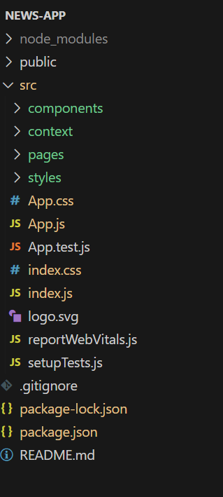

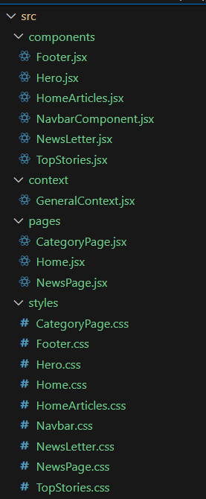

**Project setup and configuration**

* + **Installation of required tools**:
  + Open the project folder to install necessary tools

In this project, we use:

* + React Js
  + React Router Dom
  + React Icons
  + Bootstrap/tailwind css
  + Axios
  + For further reference, use the following resources
  + <https://react.dev/learn/installation>
  + <https://react-bootstrap-v4.netlify.app/getting-started/introduction/>
  + <https://axios-http.com/docs/intro>
  + <https://reactrouter.com/en/main/start/tutorial>
  + **Project Development**
  + **Project Development**
  + Setup the Routing paths
  + Setup the clear routing paths to access various files in the application.
  + Ex:  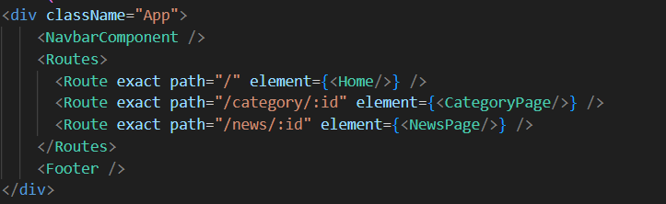
  + Develop the Navbar and Hero components
  + Code the popular categories components and fetch the categories from ***newsapi***.
  + Also, add the trending news in the home page.
  + Additionally, we can add the component to subscribe for the newsletter and the footer.
  + Now, develop the category page to display various news articles under the different categories.
  + **Important Code snips:**
  + **Fetching Top/Trending news**
  + 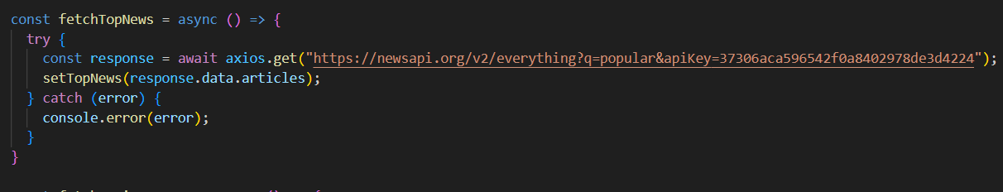
  + **Fetching news by search/category**
  + 